PROTOTYPE DESCRIPTION
Smart Safety Companion (MIT App Inventor)

Smart Safety Companion – Prototype Explanation
The Smart Safety Companion is a mobile application prototype developed using MIT App Inventor. This application serves as a personal security tool designed to monitor user safety through automated phone movement analysis. It detects high-intensity physical distress, such as strong shaking, and generates immediate emergency alerts containing precise location and directional data.
1. Purpose of the Prototype
The main objectives of this prototype are:
- To provide basic personal safety support
- To continuously monitor phone movement
- To detect sudden or abnormal shaking
- To track GPS location
- To identify device direction
- To generate and display emergency alert messages
- To store and use emergency contact numbers
This prototype works as a safety monitoring companion that can react automatically during risky situations.
2. User Interface Screen Description
a) Application Title
- “Smart Safety Companion”: This label is displayed at the top of the screen and represents the name of the application.
b) Emergency Contact Input Section
- Text boxes: Provided for entering emergency contact numbers.
- TinyDB Storage: These numbers are stored using TinyDB to remain saved even after the app is closed.
- Alert Recipient: Stored contacts are used to receive automated emergency alerts.
c) Start Monitoring Button (Green)
- Safety Activation: Starts the safety monitoring process.
- Sensor Integration: Enables the Accelerometer, Location, and Orientation sensors.
- Status Update: Changes the status label to “Monitoring” and begins real-time tracking of movement.
d) Stop Monitoring Button (Red)
- Deactivation: Stops all monitoring activities and disables all sensors.
- System Reset: Resets shake values and the status back to “Stopped”.
- User Control: Allows the user full control over the monitoring process.

3. Status and Sensor Information Display
The prototype displays live data using specific labels:
- Status Label: Shows the current system state: Stopped, Monitoring, or Emergency Detected.
- Accelerometer Values (X, Y, Z): Displays raw motion values from the X, Y, and Z axes used to calculate shake intensity.
- Shake Value & Shake Count:
  - Calculated using the formula: $|X| + |Y| + [cite_start]|Z|$.
  - New Logic: If the shake value exceeds the threshold, it increments the Shake Count. Once the count reaches 3, a confirmed emergency is triggered.
- Location Information: Displays Latitude and Longitude collected via GPS through the LocationSensor.
- Direction Information: Determined using the OrientationSensor to convert the azimuth angle into North, East, South, or West.
- Alert Message Display:
  - Automatically shows a warning when the shake count reaches 3.
  - Message Content: Includes the emergency warning, precise location, direction, and time.
  - Auto-Action: Triggers an automatic Phone Call and SMS to stored contacts when the detection count hits 3.

4. Background Design
- A technology-themed background image is used
- Improves visual appearance
- Makes the app more attractive and user-friendly

5. Block Programming Description (MIT App Inventor)
The prototype logic is created using MIT App Inventor Blocks.
Global Variables
The app uses global variables to control its behavior. Monitoring decides whether the system is active, cooldown prevents repeated alerts, shakeThreshold sets the minimum movement needed to trigger an emergency, directionText stores the detected direction, and alertMessage holds the generated emergency message.
Accelerometer Sensor:
The accelerometer runs whenever the phone moves. It checks if monitoring is active and cooldown is off, then calculates the shake value from X, Y, and Z readings while showing live sensor data. If the shake value exceeds the threshold, an emergency is detected, the status changes to “Emergency Detected,” the location and direction are determined, a message is generated, cooldown is activated, and the clock timer begins.
Direction Detection Logic
Direction is determined using the azimuth angle. Values between 315° and 45° indicate North, 45° to 135° indicate East, 135° to 225° indicate South, and 225° to 315° indicate West. This converts raw sensor readings into simple, human-readable directions.
Clock Timer Block
- Timer runs for 10 seconds,Prevents repeated alerts
- After timer ends:
  - Cooldown resets
  - App returns to monitoring mode

6. Overall Working of the Prototype
- User enters emergency contact numbers
- User presses Start Monitoring
- App continuously monitors phone movement
- If strong shaking occurs:
  - Emergency is detected
  - Location and direction are captured
  - Alert message is generated and displayed
- Cooldown prevents multiple alerts
- User can stop monitoring anytime
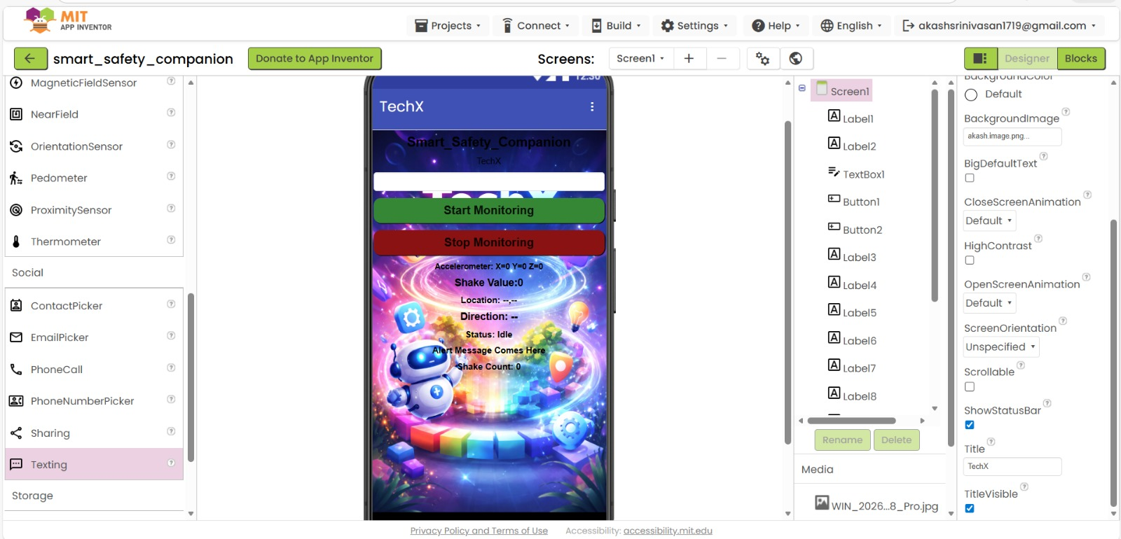

7. Conclusion
The Smart Safety Companion prototype demonstrates a simple yet effective safety monitoring system using smartphone sensors.
It shows how movement detection, location tracking, and direction awareness can be combined to assist users during emergencies.
This prototype can be extended further for:
- Women safety
- Accident detection
- Elderly assistance
- Emergency response systems.

